Project 2 TaskKeeper Application

Description :

This is a TaskKeeper application which allows any user to define and manage tasks with status of each task. This is a simple application which will demonstrate the learnings in the course FA2024-ITDEV-162-800 Client/Srvr & E-Commerce Impl. Primarily it will use the same tech-stack taught in the course : SQLite as Database, HTML/CSS/Angular for Front-end and ASP.NET/C#.NET for back-end.

Note:

[Stretch goal feature]**:** as many of the learnings are still under progress, and Angular/Front-end technology learnings will decide the end-state, depending on the complexity, some features may or may not completely get finished and rather may have only back-end APIs implemented. But at the least user should be able to perform “Getting Tasks” and “Adding Tasks” operations successfully is the goal towards Project1 assignment completion.

Feature List :

Table of Contents

[Project goal feature] Getting all tasks 2

[Screen shots] 2

No tasks 2

With tasks 3

[Project goal feature] Adding a new task 4

[Screen shots] 4

Before adding a task 4

After adding a task 5

[Stretch goal feature] Updating a task 6

[Screen shots] 6

Before Mark as Done 6

After Mark as Done 7

[Stretch goal feature] Deleting a task 8

[Screen shots] 8

Before clicking on Delete 8

After clicking on Delete 9

This application will provide following functionalities:

# [Project goal feature] Getting all tasks.

* 1. Create GITHUB repository for the TaskKeeper application
  2. Create front-end client application in Angular
  3. Create back-end server application in (C#/ASP).NET and SQLite
  4. Define and create SQL database schema for SQLite using persistence features of C#.NET
  5. Populate seed data in the database to retrieve and render data models in front-end client
  6. Design and implement ng-modules for handling retrieving new task in client side application
  7. Design and implement C#.NET classes to retrieve task in server side application
  8. Implementation of code, error handling, and testing of the feature
  9. Iterative GITHUB repository commits and merges

## [Screen shots]

### No tasks

#### Backend

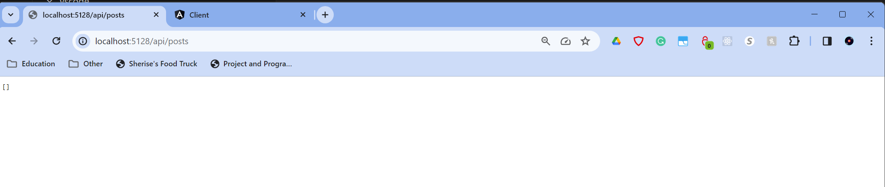

#### Frontend

### With tasks

#### Backend

#### Frontend

# [Project goal feature] Adding a new task.

* 1. Design and implement ng-modules for handling adding new task in client-side application.
  2. Design and implement C#.NET classes to adding new task in server-side application.
  3. Implementation of code, error handling, and testing of the feature
  4. Iterative GITHUB repository commits and merges.

## [Screen shots]

### Before adding a task

#### Backend

#### Frontend

#### Adding a task

#### Frontend

#### 

### After adding a task

#### Backend

#### Frontend

# [Stretch goal feature] Updating a task.

* 1. Design and implement ng-modules for handling user operations for a task update in client-side application.
  2. Design and implement C#.NET classes for handling user operations for a task update in server-side application.
  3. Implementation of code, error handling, and testing of the feature
  4. Iterative GITHUB repository commits and merges.

## [Screen shots]

### Before Mark as Done

#### Backend

#### Frontend

### After Mark as Done

#### Backend

#### Frontend

# [Stretch goal feature] Deleting a task.

* 1. Design and implement ng-modules for task deletion in client-side application.
  2. Design and implement C#.NET classes for handling user operations for a task deletion in server-side application.
  3. Implementation of code, error handling, and testing of the feature
  4. Iterative GITHUB repository commits and merges.

## [Screen shots]

### Before clicking on Delete

#### Backend

#### Frontend

### After clicking on Delete

#### Backend

#### Frontend

